**VAISHNAVI E 231901059**

**EXERCISE 3**

**IDENTITY and ACCESS MANAGEMENT AIM**:

To understand the concepts of identification, authentication, authorization, accounting (IAAA), and identity management, which are essential for securing systems and managing user access.

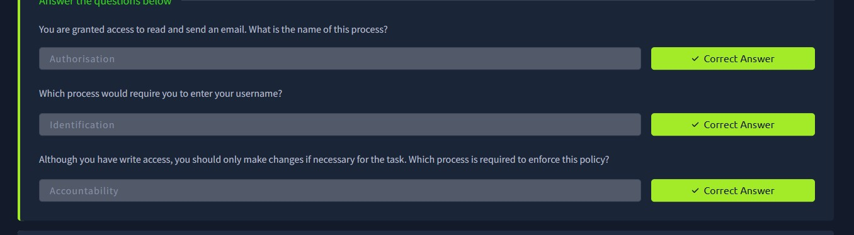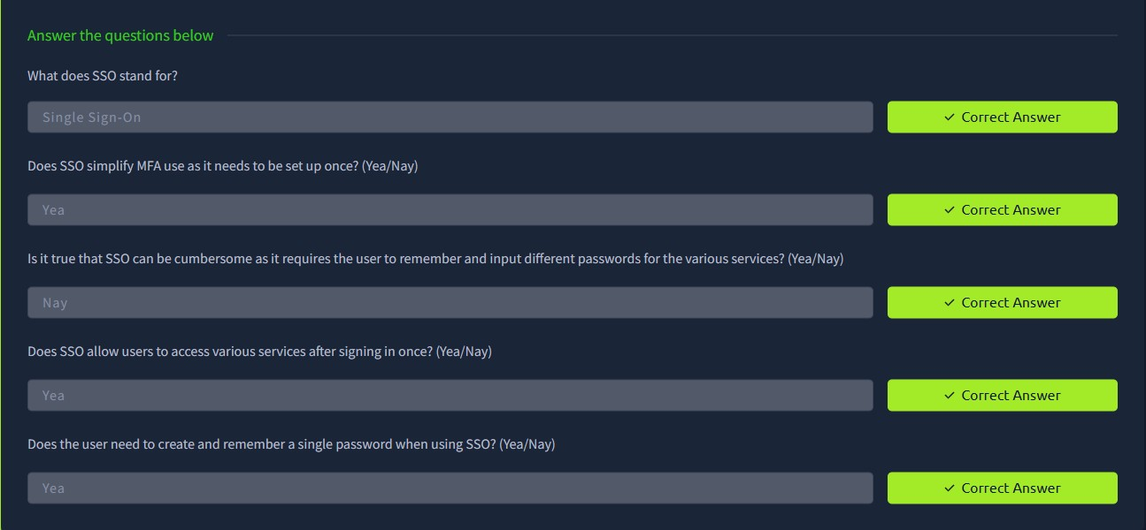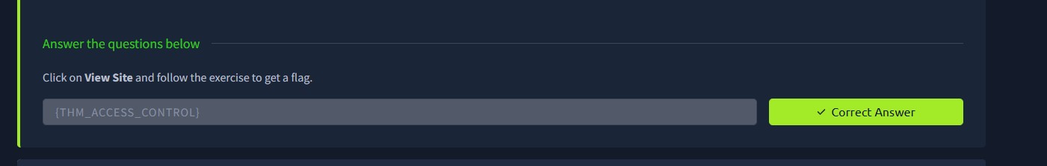

**RESULT**:

Successfully learned how identification, authentication, and authorization work together to control access, how accounting tracks user activities, and the role of identity management in maintaining security and compliance.